OPTICS EP-204

**SIMULATING DIFFRACTION**

**WITH PYTHON**

horizontal line

# 

# INNOVATIVE MID-TERM PROJECT

BY **ADITYA SINGH 2K19/EP/005**

AND **ANSHUL SATIJA 2K19/EP/018**

# TABLE OF CONTENTS

1. Introduction
2. Diffraction Pattern
   1. Single Slit Diffraction
   2. Object Edge
   3. Fraunhofer Diffraction Pattern
3. Single Slit Diffraction
   1. Derivation
   2. Intensity
   3. Graph
4. Double Slits Diffraction
   1. Intensity
   2. Graph of Pattern
   3. Maxima and Minima
5. Fraunhofer and Fresnel Diffraction
6. Convolution Theorem
7. Astigmatism
8. Python Script and Results

# 

# 

# 

# INTRODUCTION

Light is an electromagnetic wave, and like all waves, “bends” around obstacles. Light of wavelength comparable to or larger than the width of a slit spreads out in all forward directions upon passing through the slit.

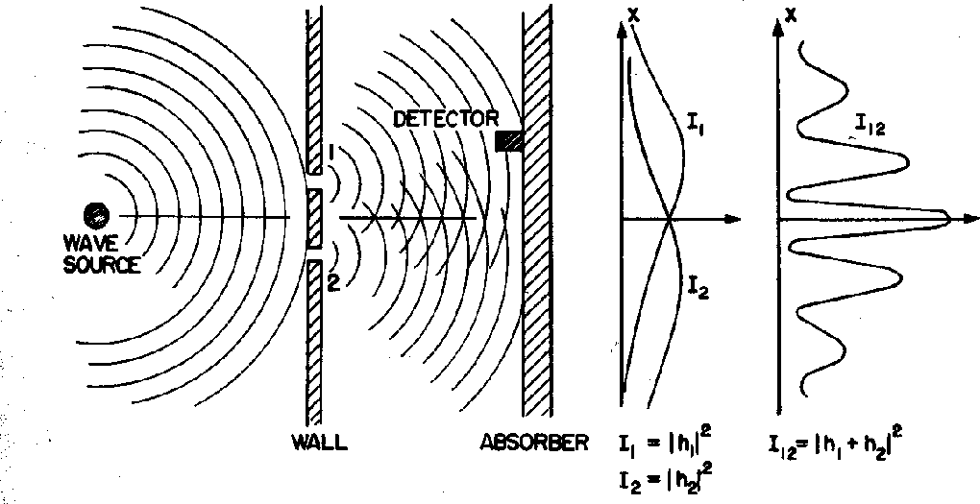

This indicates that light spreads beyond the narrow path defined by the slit into regions that would be in shadow if light traveled in straight lines.Most noticeable when the dimension of the obstacle is close to the wavelength of the light.

Diffraction is the spreading out of waves as they pass through an aperture or around objects. It occurs when the size of the aperture or obstacle is of the same order of magnitude as the wavelength of the incident wave.

# 

# DIFFRACTION PATTERN

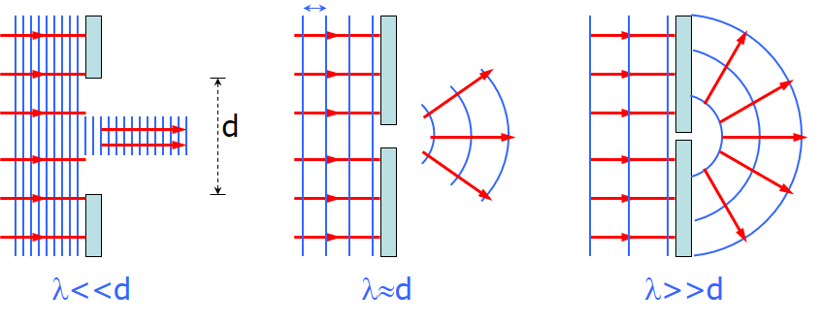

A single slit placed between a distant light source and a screen produces a diffraction pattern.

* It will have a broad, intense central band, called the central maximum
* The central band will be flanked by a series of narrower, less intense secondary bands, called side maxima or secondary maxima
* The central band will also be flanked by a series of dark bands, called minima

### 

### Single Slit Pattern

The diffraction pattern consists of the central maximum and a series of secondary maxima and minima.

The pattern is similar to an interference pattern.

### Object Edge

### 

This shows the upper half of the diffraction pattern formed by light from a single source passing by the edge of an opaque object.

The diffraction pattern is vertical with the central maximum at the bottom.

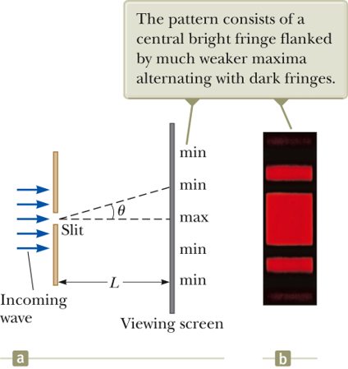

### Fraunhofer Diffraction Pattern

A Fraunhofer diffraction pattern occurs when the rays leave the diffracting object in parallel directions.

* Screen very far from the slit
* Could be accomplished by a converging lens

# SINGLE SLIT DIFFRACTION

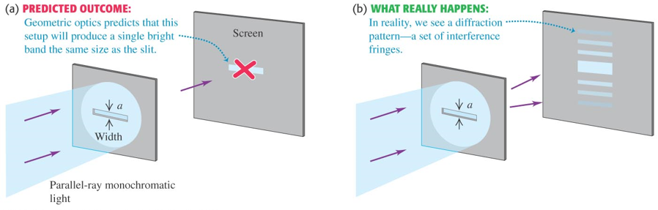

The finite width of slits is the basis for understanding Fraunhofer diffraction. According to Huygens’s principle, each portion of the slit acts as a source of light waves. Therefore, light from one portion of the slit can interfere with light from another portion.

The resultant light intensity on a viewing screen depends on the direction θ. The diffraction pattern is actually an interference pattern. The different sources of light are different portions of the single slit.

All the waves are in phase as they leave the slit. Wave 1 travels farther than wave 3 by an amount equal to the path difference.

* (a/2) sin θ

If this path difference is exactly half of a wavelength, the two waves cancel each other and destructive interference results.

In general, destructive interference occurs for a single slit of width a when sin θdark = mλ / a.

* m = ±1, ±2, ±3, …

**Intensity**

A broad central bright fringe is flanked by much weaker bright fringes alternating with dark fringes.

Each bright fringe peak lies approximately halfway between the dark fringes. The central bright maximum is twice as wide as the secondary maxima. There is no central dark fringe.

* Corresponds to no m = 0 in the equation

The intensity can be expressed as

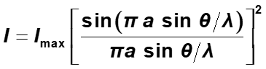

Minima occur at

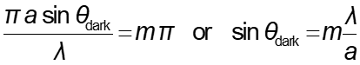

Most of the light intensity is concentrated in the central maximum.

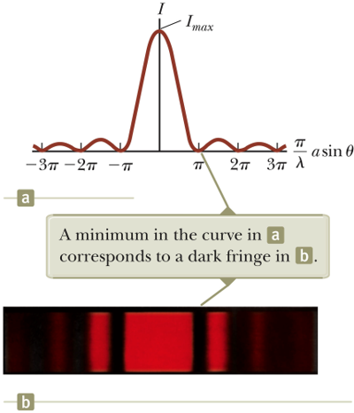

The graph shows a plot of light intensity vs. (p /l) a sin q

# DOUBLE SLITS DIFFRACTION

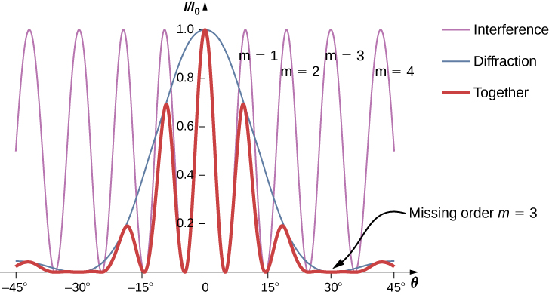

When more than one slit is present, consideration must be made of

* The diffraction patterns due to individual slits
* The interference due to the wave coming from different slits

The single-slit diffraction pattern will act as an “envelope” for a two-slit interference pattern.

To determine the maximum intensity:

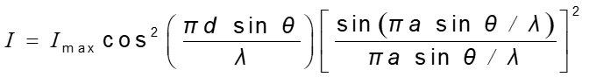

* The factor in the square brackets represents the single-slit diffraction pattern. This acts as the envelope.
* The two-slit interference term is the cos2 term.

**Graph of Pattern**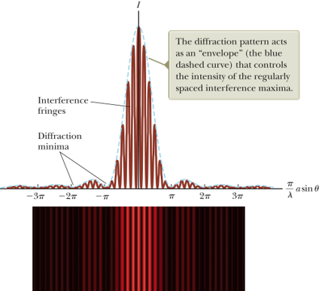

The broken blue line is the diffraction pattern.

The brown curve shows the cos2 term. This term, by itself, would result in peaks with all the same heights.

The uneven heights result from the diffraction term.

**Maxima and Minima**

To find which interference maximum coincides with the first diffraction minimum.

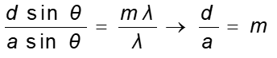

* The conditions for the first interference maximum, d sin θ = m λ
* The conditions for the first diffraction minimum, a sin θ = λ

# 

# FRAUNHOFER DIFFRACTION

Fraunhofer diffraction, describes the diffraction pattern observed in the far field where geometric optics is completely inapplicable

In Fraunhofer diffraction the rays leave the diffracting object in parallel directions.

* Screen very far from the slit
* Could be accomplished by a converging lens

# Fraunhofer diffraction is the type of [diffraction](https://scienceworld.wolfram.com/physics/Diffraction.html) that occurs in the limit of small [Fresnel number](https://scienceworld.wolfram.com/physics/FresnelNumber.html) . In Fraunhofer diffraction, the [diffraction pattern](https://scienceworld.wolfram.com/physics/DiffractionPattern.html) is independent of the distance to the screen, depending only on the angles to the screen from the aperture.

# 

# FRESNEL DIFFRACTION

In optics, the Fresnel diffraction equation for near-field diffraction is an approximation of the Kirchhoff–Fresnel diffraction that can be applied to the propagation of waves in the near field.

It is used to calculate the diffraction pattern created by waves passing through an aperture or around an object, when viewed from relatively close to the object.

The near field can be specified by the Fresnel number, F, of the optical arrangement. When 

The diffracted wave is considered to be in the near field. However, the validity of the Fresnel diffraction integral is deduced by the approximations derived below. Specifically, the phase terms of third order and higher must be negligible, a condition that may be written as



The multiple Fresnel diffraction at closely spaced periodical ridges (ridged mirror) causes the specular reflection; this effect can be used for atomic mirrors.



# CONVOLUTION THEOREM

To handle more complex cases of diffraction using Fourier transforms we need to know the convolution theorem. Say g(x) is the convolution of two other functions f and h. Then



The blue line represents the function h(x−x′), the red line the function f(x) and the green line is the convolution. In the animation; follow the vertical green line that is the point where the convolution is being evaluated. Its value is the area under the product of the two curves at that point.



The convolution theorem states that if

G(k)=Ϝ{g(x)},

F(k)=Ϝ{f(x)}

and H(k)=Ϝ{h(x)}

and if g(x)=f⊗h, then => G(k)=F(k)H(k)

Now say we want to consider the case of two long slits with width a. This can be described by the convolution of one slit with two delta functions.



So two slits of a finite width can be described by the convolution of two delta functions and rectangular aperture function.

Then the Fraunhofer diffraction pattern is just the product of the two Fourier transforms.

To summarize: Fraunhofer diffraction patterns are the Fourier transform of the aperture function.

The Fourier transform of the convolution of functions is the product of the Fourier transforms of the individual functions.

# 

# ASTIGMATISM

Astigmatism is a type of refractive error in which the eye does not focus light evenly on the retina.

This results in distorted or blurred vision at any distance. Other symptoms can include eyestrain, headaches, and trouble driving at night.

Astigmatism usually occurs at birth, but can sometimes develop later in life. If it occurs in early life, it can later result in amblyopia.

The cause of astigmatism is unclear, however it is believed to be partly related to genetic factors. The underlying mechanism involves an irregular curvature of the cornea or abnormalities in the lens of the eye.



Three treatment options are available: glasses, contact lenses, and surgery. Glasses are the simplest. Contact lenses can provide a wider field of vision. Refractive surgery permanently changes the shape of the eye.

# PYTHON SIMULATION ([Code Link](https://colab.research.google.com/drive/1p-UGYYzRtX96N0pkIJklXb7V0zqcNZLg?usp=sharing))

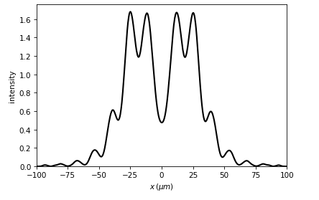

Diffratio is a Python library for Diffraction and Interference Optics.

It implements Scalar and paraxial vector Optics. The main algorithms used are Rayleigh Sommerfeld (RS), Beam Propagation Method (BPM) and Fast Fourier Transform (FFT). When possible, multiprocessing is implemented for a faster computation.

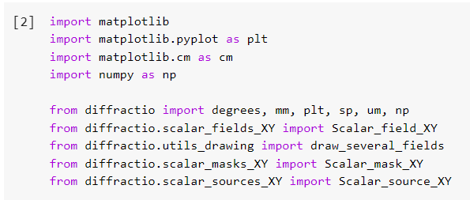

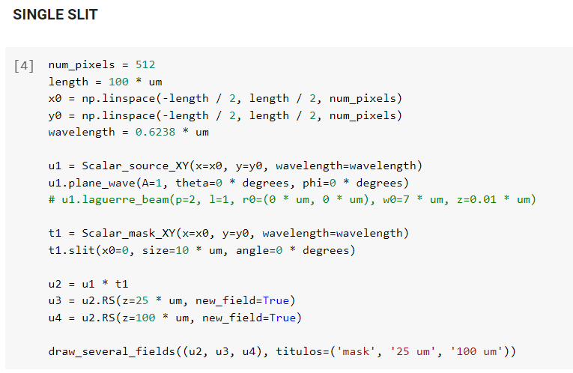

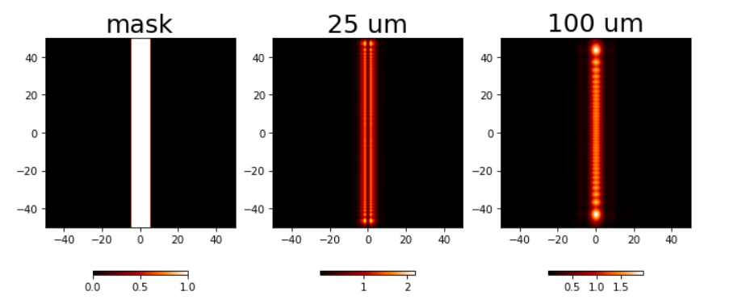

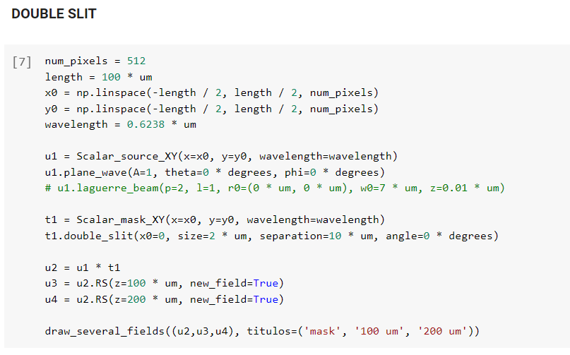

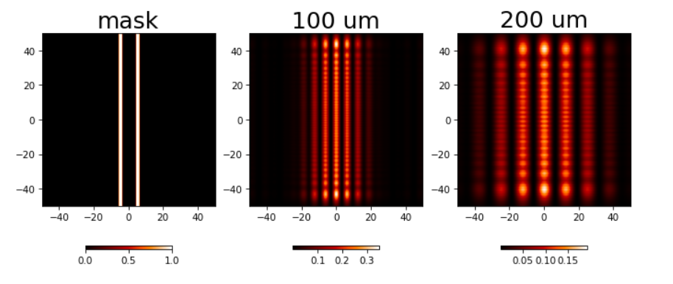

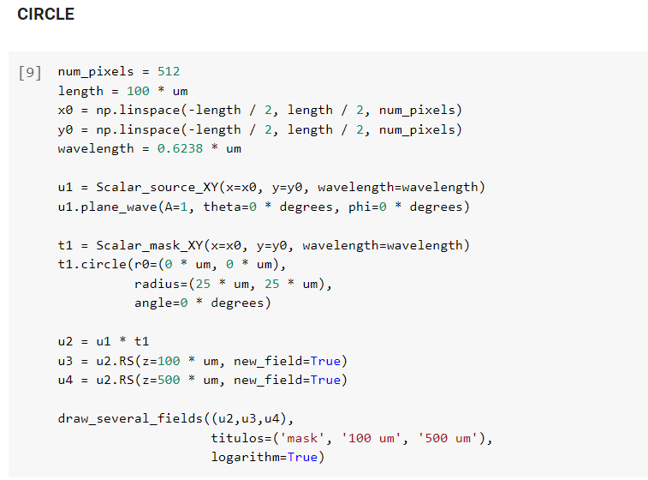

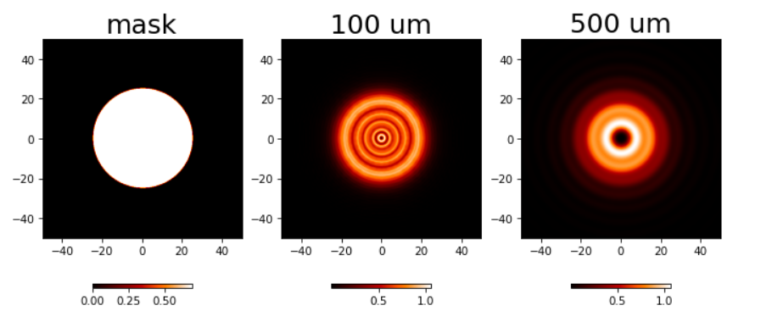

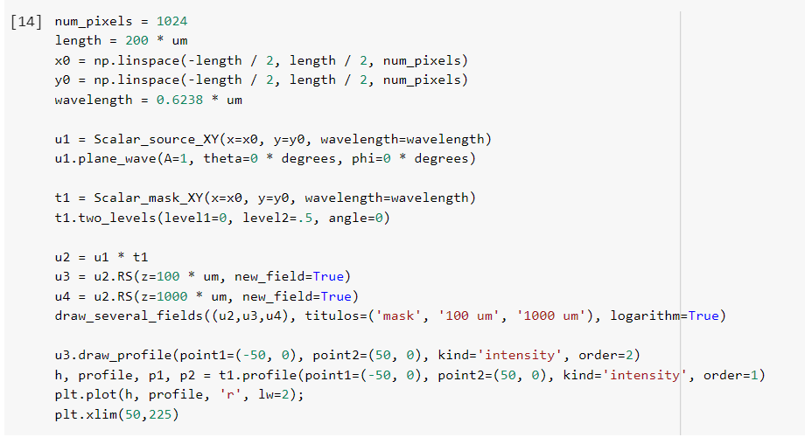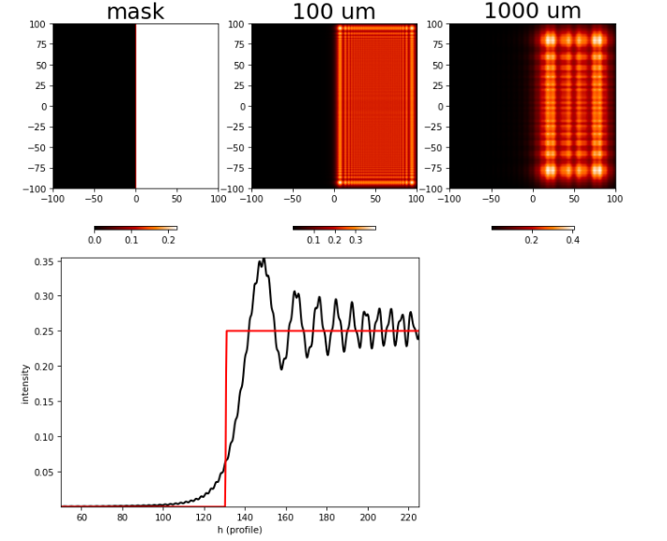

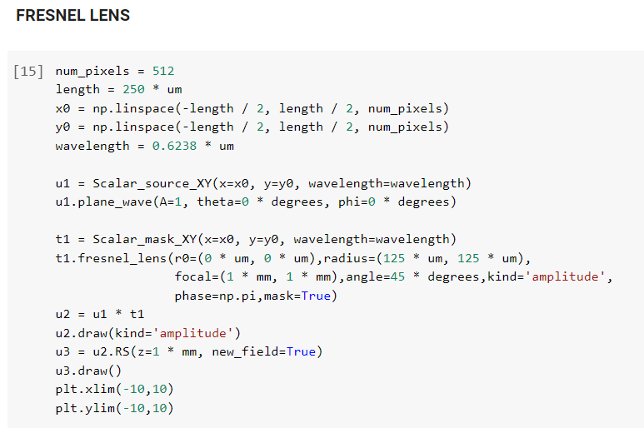

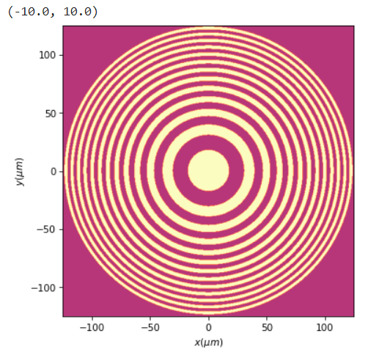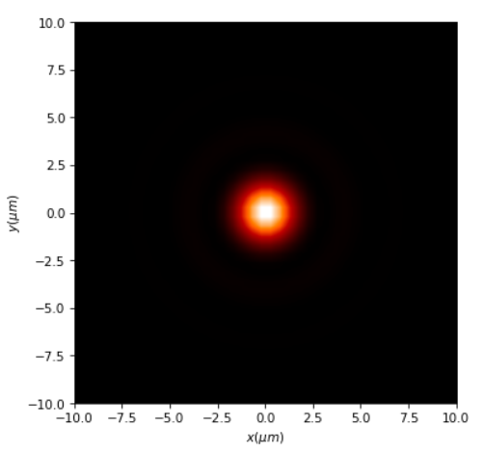

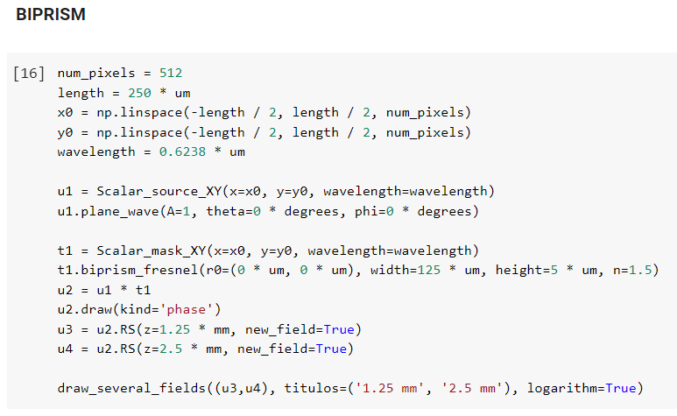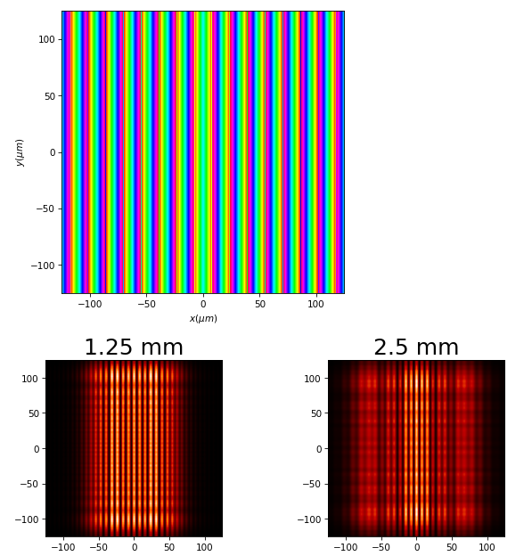

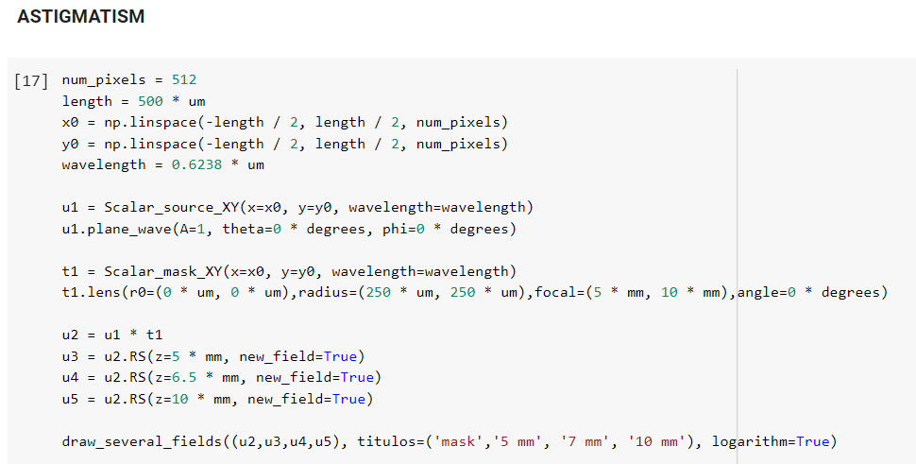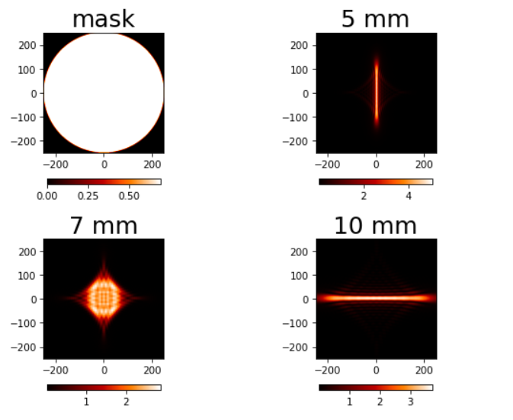

**THANK YOU**